Laboratory Manual

BME 3506C Circuits for Bioengineers
Dr. Fernando Gonzalez
Fall 2025

Requirements
- You may work on the experiment in groups of 2.
- You must turn in a lab report for each lab. The report must include the lab assignment, the data you or your partner gathered, all necessary circuit diagrams, all necessary equations you used and any other relevant material that will allow me to access your work to produce a grade.
- In the report you must answer any questions in the assignment.
- In the report you must present all your results nicely tabulated and with neat diagrams.
- In the report you must explain what you are doing.
- The report should be very professional looking and clear.
- You must take the equipment and parts you need from the cabinet and return them before you leave.
- You are NEVER allowed to take any equipment of parts home. Doing so is considered stealing.
- Please keep the cabinets and lab organized.

Breadboard
The breadboard is connected such as to allow you to wire circuits easily. The holes in the breadboard allow you to insert a wire of about 22 AWG or a 0.1” leg. The short horizontal rows with 5 holes are all connected. The long vertical rows are also all connected and are generally used for the power supply.
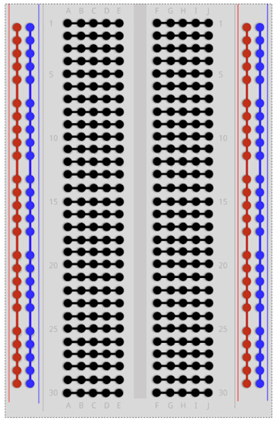 | 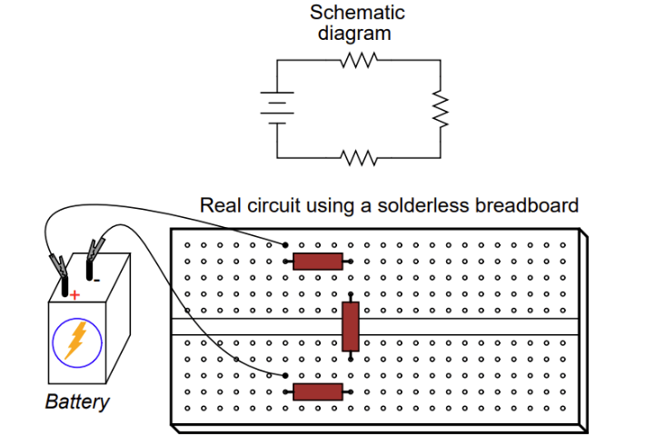
The connections of a breadboard | Example circuit wired on a breadboard.

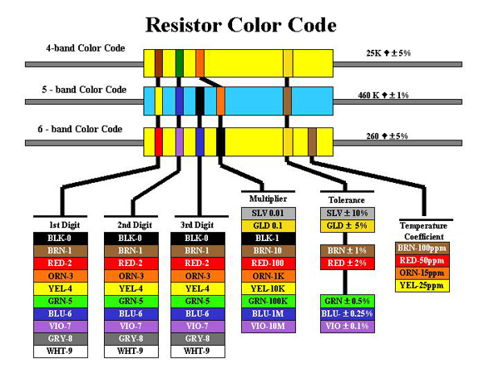
Extracted from the DigiKey Tutorial.
The blue colored resistors are made of a fire-resistant material. These are often found in automotive circuits.
Example:
A red/red/black resister has a value of 22 Ohms
red (2)-red (2)-black (0) = 22 ohms
A Yellow/violet/orange has a value of 47K Ohms.
yellow (4)-violet (7)-orange (3) = 47,000 Ohms

Lab 1: Resistive Circuits
Purpose: to gain familiarity with the lab equipment, multi-meters, breadboard, power supply, resisters, resister codes, and Ohm’s Law.

Part 1 Resister values, colors and tolerances
Select any 3 resistors with different resistance values of which at least 1 be < 100 Ohms and another be greater than 1M Ohm. For each resister measure the actual value using the multi meter. Then fill in the table using the coded resistor value, coded tolerance, measured value and measured tolerance. A resister codes chart is in this manual.

Resistor  Number | Coded  Value | Coded  Tolerance | Measured  Value | Measured Tolerance
1 | 20 ohms | +-5.0% | 20.3 | 1.5%
2 | 120k ohms | +-5.0% | 119.4 | .5%
3 | 2 m ohms | +- 5.0% | 2.1m | 5%

Note the measured tolerance can be computed using the formula below.

Part 2 Measuring voltages and currents
Setup the following circuit using any resistor.
Using a 1K Ohm resistor, vary the supply voltage from 1V to 12V in increments of 4 volts and measure the voltage across the resistor and the current through the resistor and tabulate the data. Then compute the power using the 3 different equations.
Resister | 0V | 4V | 8V | 12V
V (volts) | 0.00 | 4.004 | 8.00 | 12.00
I (Amps) | 0.00 | 0.004 | 0.008 | 0.012
 | 0 | 0.016 | 0.064 | 0.144
 | 0 | 0.016 | 0.064 | 0.144
 | 0 | 0.016 | 0.064 | 0.144

- Draw the graph of the voltage versus the current.

- Comment on the work. What is the slope of the curve in terms of I, V, R.

The slope of the graph is V/I=R. In this experiment our slope is 1000 or 1000 ohms

Part 3 Circuit analysis
- Set up the following circuit.
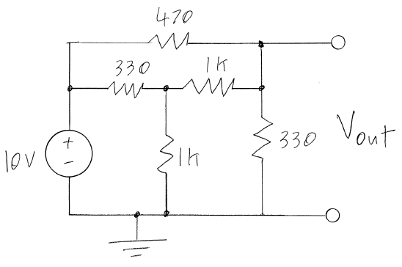
- Using nodal analysis or mesh analysis and series and parallel circuit principles calculate the voltage at each node.
- Measure the voltage at each node and calculate the error using the error formula.
- Calculate the power dissipated by each resister and add them up to compute the total power dissipated.
- Measure the power delivered by the power source. You can do this by measuring the voltage and current output and multiply.
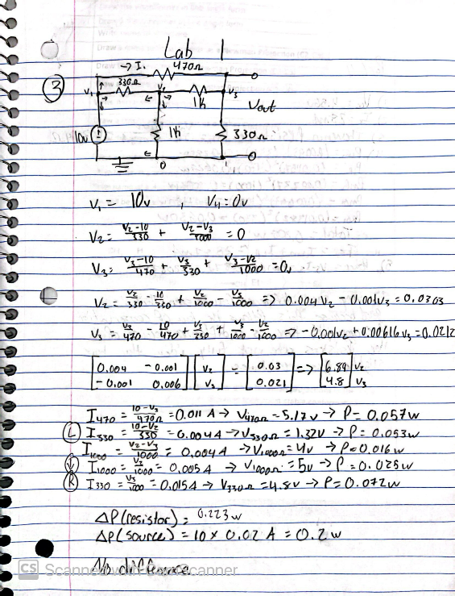
- Is there a difference between the total power delivered by the source and the total power dissipated by the resisters? Should there be a difference?

Part 4. Thevenin equivalent circuits
Design and implement a Thevenin equivalent circuit for the following circuit.
 | 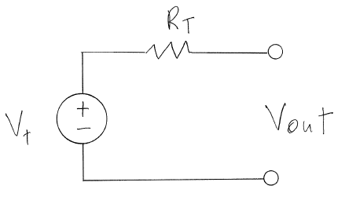
a | b

- Using the circuit in part 3 (a above), measure the open circuit voltage, by using the multi-meter across the terminals.
- Measure the short circuit current, , by placing the multi-meter across the terminals and set it to measure current. Note the multi-meter in current mode creates the short.
- Calculate the Thevenin resistance and voltage and implement the Thevenin equivalent circuit (b above).
- Test the validity of the Thevenin circuit by measuring the open circuit voltage, short circuit current and the power off resistance.
- To measure the power off resistance, remove the power supply and replace it with a wire shorting the terminals where the power supply connects to. Then measure the resistance by either directly with the multi-meter or by applying a voltage at the terminals across V_{out} and measuring the resultant current as you did in lab 1.
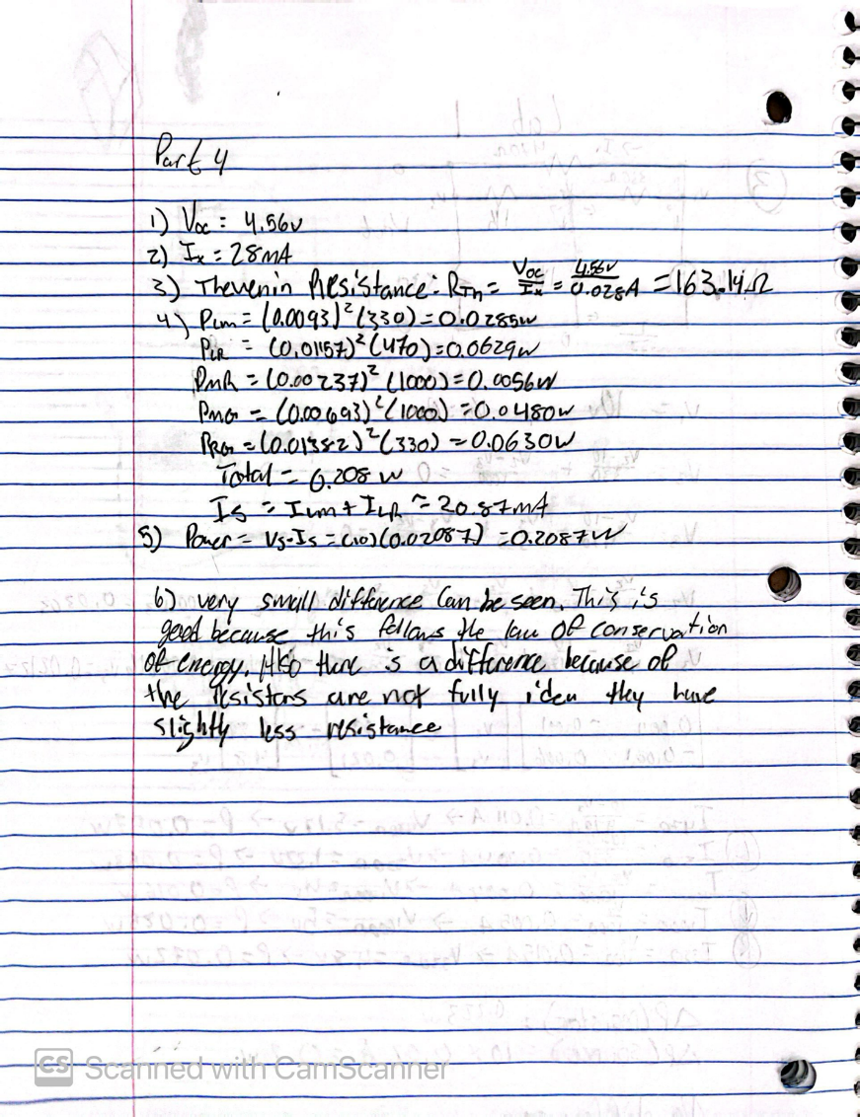
- Is the Thevenin circuit (b above) equivalent to the circuit in a above? Comment.

